Coding Challenge from Hacker Rank

1. **Arrays: Left Rotation**

A left rotation operation on an array shifts each of the array's elements unit to the left. For example, if left rotations are performed on array[1,2,3,4,5], then the array would become[3,4,5,1,2].

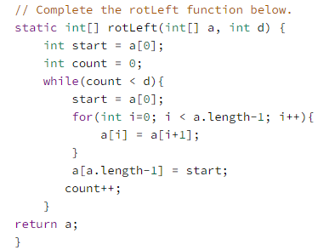

# New Year Chaos

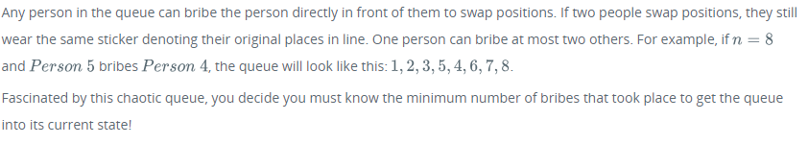

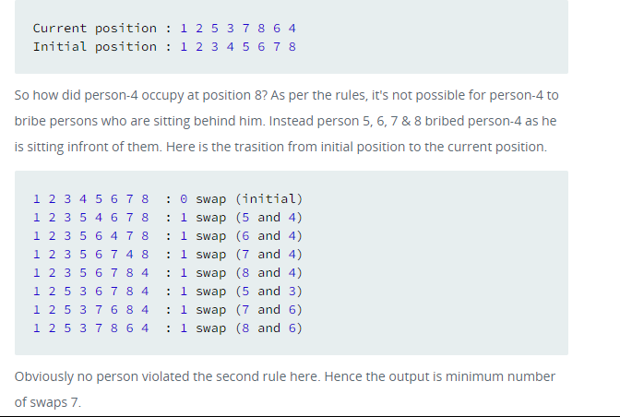

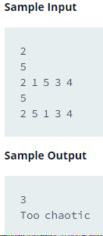 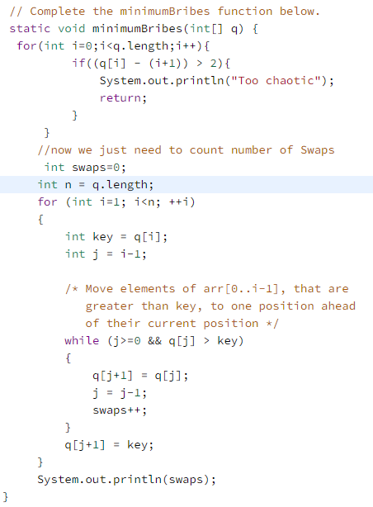

# 2D Array – DS

# 

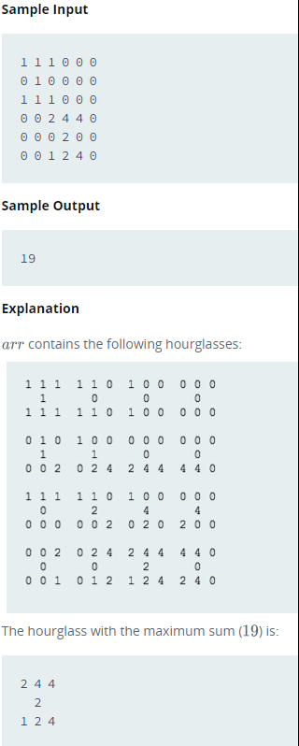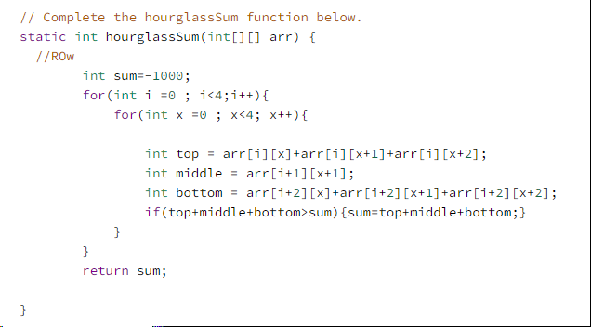

# Minimum Swaps 2

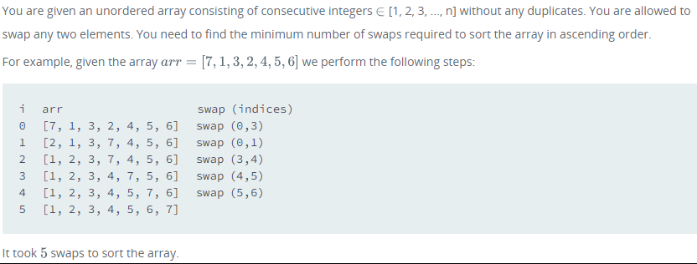

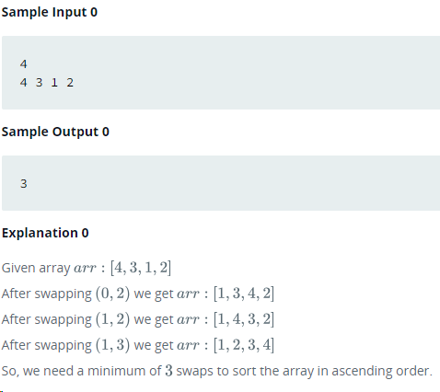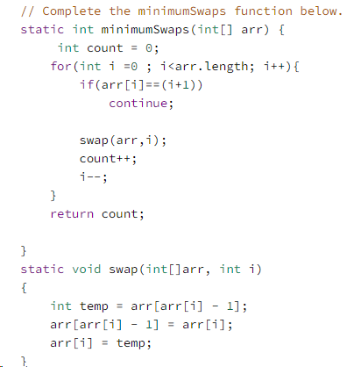

# Array Manipulation

Starting with a 1-indexed array of zeros and a list of operations, for each operation add a value to each of the array element between two given indices, inclusive. Once all operations have been performed, return the maximum value in your array.

For example, the length of your array of zeros n=10. Your list of queries is as follows:

# 